
Initial System Set Up
Projected Install Date:
Hours of Business Operations:
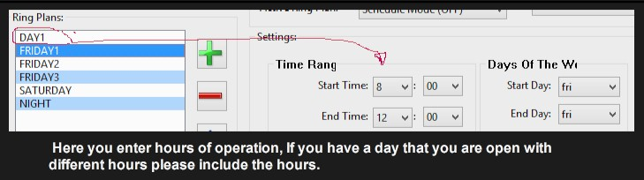

Monday – Friday Other Menu's needed
Saturday
Sunday

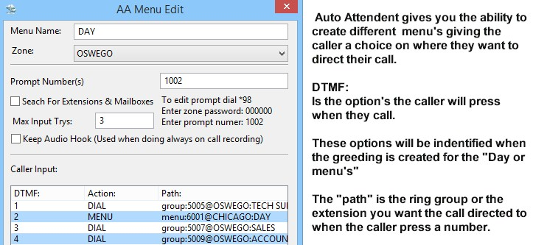

Do you have a need to put phone system in Auto Attendant mode sometimes during open office hours?
If yes please check .
Do you need a lunch Menu? YES / NO (Please circle one)
Do you need the lunch menu to be set to a certain time every day to roll over automatically? YES / NO
If yes what time:
If no does anyone need to have that ring plan over ride button on the phone so you can set it manually? YES/NO If yes what extensions need it:
What do you want the system to do if no one picks up the call after how many rings during the day?

○ Do you want system to automatically go into Night Mode? Please Check
○ Do you want system to only go into Night Mode manually? Please Check

Incoming Calls
Would you like phone or phones to initially ring after rings, or go to an auto-attendant before ringing phones?
If going to and auto-attendant what auto-attendant do you want it to go to and what options do you want in the menu?

Immediate Ring Extension/Staff

Delayed Extensions/Staff members

System Set Up Continued

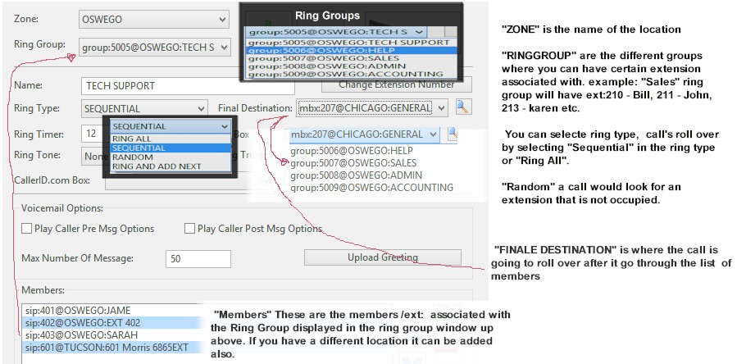
If no one is able to answer the phone where would you like the caller to be sent? (Example: General
Mailbox, Day Menu or Auto Attendant Menu)
What extensions would you like to start with Example: 10 / 100 / 1000 / 10000
20 / 200 / 2000 / 20000
Please circle the extension numbers you want to use or write them next to the name in department.
Please List Name or Department for Telephone Extensions along with extension choice.
List Name or Department listed on telephone. Example John or Sales

Department: | Department:

Department: | Department:

Department: | Department:

If you have multiple numbers please list what they are and where you want them to go, like to a certain ring group, person, menu or mailbox.
Number: | Destination:
1)
2)
3)
4)
5)
6)
How many ring group will you need?

Please write down the ring groups you need and what number, department or extensions need to be in them.

Name of Ring Group: | Ring group Includes:
Name of Ring Group: | Ring group Includes:
Name of Ring Group: | Ring group Includes:
Name of Ring Group: | Ring group Includes:
Name of Ring Group: | Ring group Includes:

Voicemail

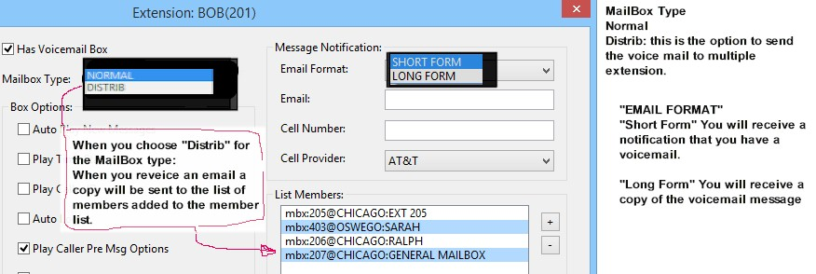

Are you going to need a General Mailbox? YES/NO
If yes when your General Voice Mail takes a message would you like other ext/exts to get the messages? YES/ NO
If yes what extension/extensions does it go to:

Will you need a separate Voice Mail that takes messages at night? YES/NO
If yes do you want them to stay in the mailbox or go to any other extensions?

Will you need any other general mail boxes and if so do they need to go to any other extensions? YES/NO
If yes please fill out info:
General Mailbox Name: | What extensions does it need to go to?
General Mailbox Name: | What extensions does it need to go to?
General Mailbox Name: | What extensions does it need to go to?
General Mailbox Name: | What extensions does it need to go to?

Additional Information:
Where would you like the phones to go in case of power outage?

Is your E911 information at the same as your service address? YES / NO (Please circle one)
If no, what is the service address?

What do you want your outbound caller ID to say?
Do you have any special requirements or request for a feature you would like to have?

